Portal API .NET SDK Manual
Portal API .NET SDK Manual
Impro Technologies
2015
Table of Contents

Document Control 2
Revision Control 2
Using Portal .NET SDK 3
Performing Hibernate SQL Queries 5
Saving data to the Portal API 5

Document Control

Item | Portal API .NET SDK Manual
Impro Technologies Reference Number | PSNM_01_2016
Authors: | Clive van Eeden
Security Level: | Confidential – Not for redistribution without consent.

Revision Control

Revision | Dated | Revised By | Description of Major Changes
1.0.0 | 2016/01/20 | Clive van Eeden | Portal .NET SDK
1.0.1 | 2016/07/04 | Clive van Eeden | Added secure setting change

Using Portal .NET SDK

This document is based on the PortalSDKSample.csproj which has all the examples you see here to connect, save etc. already. Please consult the code for more insight.
Before you continue using the Portal SDK you will first need to open SQL Server Management Studio, open up the Portal database, open up the tables, in the CONFIGURATION table there are 2 settings to take note of:
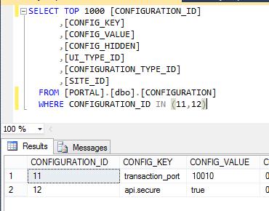
transaction_port – is the port that allows SDK Clients to connect to the Portal Server on. This does not need to change from 10010.
api.secure – this is ‘true’ by default. Changes will require a restart of Portal for the change to take effect.
To Begin an integration project into Access Portal, open Microsoft Visual Studio and click FileNew project. Select the type of project you will design (Forms, Console etc.) and say OK.
First thing to do is reference the PortalAPI.dll and the BouncyCastle.Crypto.dll (this library is required for the API to connect securely). Right click on references and then browse for the library files:
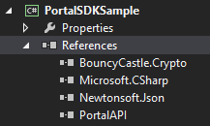

Now that we have referenced the libraries we can begin coding. For this example we are creating a forms application.
First thing to do is declare the library usage (using Portal.Api and Portal.Api.pvt) and declare the PortalAPI as your class’ variable:
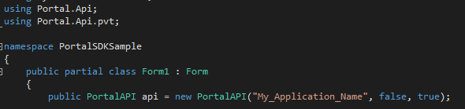
The declaration is new PortalAPI(“Your_Application_Name” , secure[true or false], debug[true or false]). So firstly the name of your app so Portal can identify the requests for auditing purposes, secondly whether the requests will be encrypted or not (true or false) and thirdly whether or not you want your app to receive back debug messages (true or false).
Now to make a connection we simply call the api.connect and then api.login to get started:
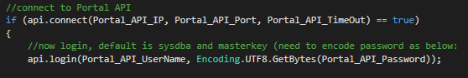
Now we are connected, we can do stuff.
NB: The secure setting must be in line with Portal’s setting. In the Portal database there is a table called CONFIGURATION, in there is a setting ‘api.secure’. If this is set to true then all connections using the API SDK have to be true. However this does require an Enterprise license or a Portal Pro + API license key. For Portal Basic change this too false in the CONFIGURATION table (this is a manual change for now and Portal will need to restarted for the change to take effect) and connect using secure=false from the API SDK.

Performing Hibernate SQL Queries

Before performing any calls to the API you need to be familiar with the protocol.xsd document found in your Portal installation under ‘C:\Portal\ net\impro\portal\server\api\xsd\’ folder. All table and column names are CASE sensitive. Which means you have to copy the names as you see them in the protocol.xsd document.
In the sample app provided the method ‘HibernateSQLQuery()’ is an example of how to do this. An example of it is:
baseDomain[] MasterIDNumSearch = api.findByHsql("from Master where mstIdnumber='12345’");
This returns an Array or List, so you need to iterate through the results. Consult the sample app for more documentation and understanding, there are comments to follow for your understanding and the sample has an example.

Saving data to the Portal API

As per the sample, to save to the API you need to build up the objects, for example inserting a MASTER record will require you to call the PortalAPI master object:
master m = new master();
Then you will build up the values as you go along e.g.:
m.firstName = FirstNameTextBox.Text;
m.lastName = LastNameTextBox.Text;
m.displayName = DisplayNameTextBox.Text;
Etc.
If you don’t specify m.id(MASTER_ID) then the API will assume it’s an insert. Otherwise if you know the MASTER_ID then specify m.id = “7” after master m = new master();. This being whatever the MASTER_ID actually is in the database, which can obtained by doing a Hibernate SQL query to search by ID number or which combination of where clauses you need.
Obviously some fields are required as per the database schema, consult the PORTAL database tables and check the whether the columns allow nulls or not. Not having a value or assigning a value for a required field will fail the insert.
There some primary keys in tables that are referenced on other tables, for example the MASTER table has SITE_ID which references the SITE table and PROFILE_ID which references the PROFILE. In which case you need to build those objects separately and then assign them to the MASTER object before saving, e.g.:
site s = new site();
s.id = MasterSiteComboBox.Text;
Then assign the master object:
m.site = s;
Once your object is built up you can then call the save update method:
api.saveOrUpdate(m);
Or if you want to return the master object after you have saved:
master m_return = api.saveOrUpdate(m);
m_return will have your entire MASTER data attached with it after this point which you could typically use to update your frontend.
Some other tables are little more complex where they are an array, for example MASTER_DETAIL table. So your MASTER object has many MASTER_DETAIL objects. For an Insert these only get saved after you saveOrUpdate the master object as per sample app. Else if you have the MASTER_ID value you can just update by creating new master object, declaring the id and then continuing with the MASTER_DETAIL table (or any other linked table) like so:
master m = new master();
m.id = "7";
And then build up the MASTER_DETAIL object and assign it to m (the master object in this example) then saveOrUpdate the m object.
For all other Portal tables the same rules and concepts apply.

